Emissions Reduction Plan – the following is excerpted from the Pou Take Āhuarangi, November 2021 Q4 report to the NICF

At a glance;
- the current settings and proposed new changes in the ERP will not reduce emissions enough to hit the first emission budget's target.

- the government said its policies will not, by itself, be enough to meet the full extent of any emissions budget and it needs additional proposals and commitments from the private sector in order to close the gap.

- Reductions in transport, energy and industry sectors are the focus of the first emissions budget, as this is where the most efficient and cost-effective reductions can be made in a short period of time.

- the He Waka Eke Noa programme - due by 2025 – is meant to measure and reduce agricultural emissions or be forced into the emissions trading scheme. Currently this sector is the largest emissions profile in the country 48 percent of our gross greenhouse gas emissions, and it is exempt from the ETS.

- Fonterra Ltd is the largest private company source of emissions with 12,333,330 annual CO2e tonnes of exempt Emissions. The next highest exempt agricultural source of emissions is Silver Fern Farms Limited with 3, 850, 726 annual CO2e tonnes.

On 13 October 2021 the government released the ERP discussion document called ‘Te hau mārohi ki anamata - Transition to a low-emissions and climate-resilient future’ – a copy was forwarded that morning to the NICF Secretariat for distribution to all Chairs and Technicians, highlighting the 6-week consultation period ends 24 November 2021.

We prepared this Summary Analysis on the ‘Te Hau marohi ki anamata’ discussion document, to provide iwi technicians, hapū and whānau with a briefing including contextual overview for participation in discussions and input into the Emissions Reduction Plan.

1. Overview
1.1 Under the Paris Agreement Climate Accord (Paris Agreement), New Zealand agreed to reduce greenhouse gas emissions by 30% below 2005 levels by 2030. The reduction target is in response to the central aim of the Paris Agreement to “strengthen the global response to the threat of climate change by keeping a global temperature rise this century well below 2 degrees Celsius above pre-industrial levels and to pursue efforts to limit the temperature increase even further to 1.5 degrees Celsius”.

1.2 In response to the Paris Agreement the Government introduced the Climate Change Response (Zero Carbon) Amendment Bill to amend the Change Response Act 2002 (the CCRA) to recognise the different impacts of greenhouse gasses and set separate targets for
- long lived greenhouse gasses to reach net zero by 2050; and
- emissions of biogenic methane emissions of reduce to 10% below 2017 levels by 2030 and to at least 24–47% below 2017 levels by 2050.

  - The amended CCRA includes the establishment of the Climate Change Commission (the Commission).

  - An important function of the Commission is to act independently of the Government of the day to provide impartial advice based on best available evidence and information [including mātauranga Māori] that is free from political interference and to challenge and hold the government of the day to account for action [or inaction] on climate change through monitoring and reviewing progress to meeting emissions targets.

  - While there are no mandatory appointments to the Commission for iwi, hapū or Māori that would give effect to the Te Tiriti o Waitangi partnership (Te Tiriti) Lisa Tumahai, Kaiwhakahaere of Te Rūnanga o Ngāi Tahu and co-chair of the Pou Take Āhuarangi – Cliamte iwi leaders group, is currently the deputy chair of the Commission.

  - The first advice provided by the Commission to the Government is the “Ināia tonu nei: a low emissions future for Aotearoa” report (the Ināia tonu nei report) that includes 33 wide-ranging recommendations. Given that iwi and hapū have values, interests and aspirations that traverse the four well-beings, including the productive utilisation of Māori and freehold land, recommendations of particular interest include:
- Emission budgets for the first three emissions budget periods;
- Specifying rules to account for emissions and measuring reductions;
- Compliancy with Te Tiriti partnership, inclusive engagement with iwi, hapū and owners of Māori land including advancing a fair, inclusive and equitable transition to a low-emission economy;
- Reducing emissions from all sectors of the economy [all relevant to iwi, hapū and owners of Māori land] including agriculture, forestry, transport, waste, industry and electricity;
- Enabling and sustaining emission reductions through a more integrated approach to land use planning [including avoiding unintended consequences of land use change]; and
- Increase circularity of the economy and enable transition to a thriving, climateresistant bioeconomy;

  - In terms of context, the Commission concisely summarised the key problem facing New Zealand, particularly with our historical track record of reliance on mitigation and offsets by saying,
“Instead of putting policies in place to decarbonise the economy and develop lowemissions technologies, practices and behaviours, Aotearoa used forests planted in the 1990s to offset its emissions and meet its targets.
The carbon removal benefits of these forests are now coming to an end.
Gross emissions have increased by 26% since 1990 and Aotearoa is in a position that is more difficult than it might have been if it had started developing the structures, strategies and plans it needs to create a low emissions system earlier.”

  - The CCRA sets out the “Zero carbon framework” which is represented pictorially in the discussion document and shown in figure 1 below.

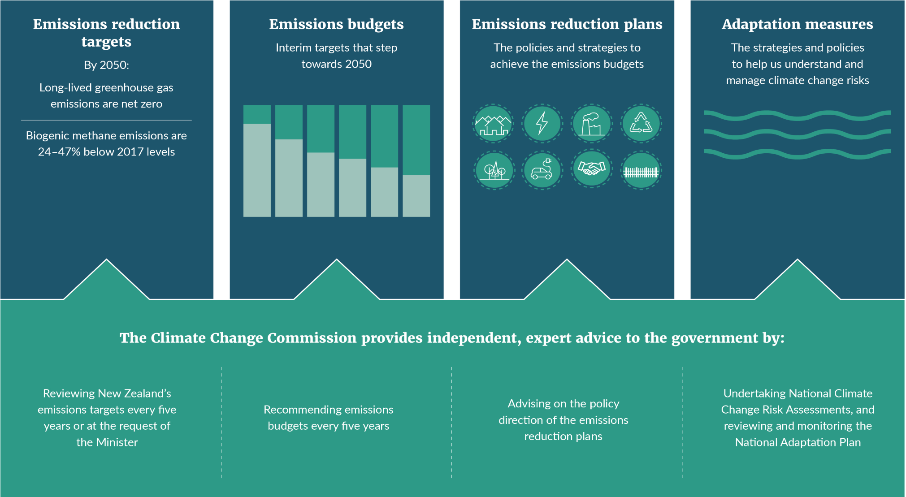

Source: Figure 1 – Page 9 of “Te hau mārohi ki anamata - Transition to a low-emissions and climate-resilient future” discussion document.

    - The zero-carbon framework is effectively a stepped process that is predicated on achieving the emissions reduction targets by 2050 through a series of interim targets [known as emission budgets] which are set for a specific period of time. Each emission budget is paired with a customised emission reduction plan that includes a range of policy settings and measures to achieve the interim targets. The Commission will also provide advice to the Government on the risks Aotearoa faces from a rapidly changing climate and how we can adapt to address these risks

    - The Commission set out eight principles for a low-emissions transition strategy which should be adopted by the Government to frame all successive emissions reduction plans.
The eight principles are:
- Transition in an equitable and inclusive way [The path Aotearoa takes should aim to reduce or even reverse inequities on different groups of society, not compound historic grievances with Iwi/Māori, and not penalise early movers];
- Take a long-term view to 2050 and beyond [Actions that are taken in the next five years will need to set Aotearoa up to deliver the deeper reductions required in subsequent emissions budgets to meet and sustain the 2050 targets];
- Prioritise gross emissions reductions [Aotearoa should prioritise actions that reduce gross greenhouse emissions rather than reducing production; noting that removing and storing carbon through forestry will still play an important role but should not displace making gross emissions reductions];
- Create options and manage uncertainty [Uncertainty is not a reason for delay; there is value in creating options for meeting targets with flexibility to adjust course as the transition proceeds to spread risk and make the transition more resilient]
- Take a systems view [People should consider the dynamics and interconnections, what opportunities they could bring, and the potential for unintended consequences];
- Avoid unnecessary cost [Using measures with lower costs and planning ahead so that technologies, assets and infrastructure can be replaced with low-emissions choices will help to avoid scrapping assets before the end of their useful lives or being left with stranded assets]
- Increase resilience and manage risks [Where possible, actions should increase the country’s resilience to the impacts of climate change that are already being experienced and that will increase in the future]; and
- Leverage co-benefits [Co-benefits can provide further reason to take particular actions where the initial emissions reductions may be modest or appear relatively costly].
1.9 The Commission usefully modelled the economic impact of meeting the 2050 targets as equating to between a 1.2-2.3% reduction in New Zealand’s GDP based on the assumption that New Zealand acts now. In stark relief, recent research from the Swiss Re Institute suggests the word economy could lose up to 18% GDP if no action is taken to reduce global greenhouse gas emissions versus a reduction of just 4% if the 2050 Paris Agreement targets are met.
The clear message being the economic costs of doing nothing far outweigh the economic costs of meeting the Paris Agreement targets.
The Commission’s recommendations and the initial response of the Government are the subject of the “Te hau mārohi ki anamata - Transition to a low-emissions and climate-resilient future” (discussion document).

- Te hau mārohi ki anamata - discussion document
  - The purpose of the discussion document is to “encourage discussion on the shape of the first emissions reduction plan” which will be published in May 2022.

  - The content of the initial emission reduction plan is said to build on existing policy settings and measures currently in play to achieve the interim targets set in for the 2022-25 emissions budget. The interim targets for the first three emissions budget periods [2022-2025, 2026-30 and 2031-35] were recommended by the Commission. The discussion document records the Government has agreed in principle to set emission budgets largely in line with Commission recommendations with adjustments for new information relating to increased afforestation. It is important to note that modelling by the Government agencies suggests existing policy settings and the measures currently in play will fall short of the interim emission reduction target for 2022-25 by approximately 7.7 Mt CO₂e¹³. In simple terms, this means the emissions reductions plan needs to tune existing policy settings and measures or put in place new policies and measures to “find” the shortfall to meet the interim target by 2025.

  - There is, however, the risk that working through a series of 5-year staged reduction targets lowers our horizon and we get locked into short-term thinking. The Commission considered this risk in shaping the low-emissions strategy principles and is of the view that we must adopt a longer-term lens to tackling subsequent reduction targets. Therefore, it is critical that the Government puts in place and implements a range of new policies and measures that deliberately have a longer-term horizon to effectively reduce New Zealand’s greenhouse gas emissions over time. Failure to adopt a long-term view at an early stage in our journey, will simply mean that it is substantially more difficult and costly in the future to make up ground. From an iwi and hapū lens, the risk of short-term thinking is likely to ultimately fall on at-risk communities as “hard measures” that become necessary in a short timeframe and without the necessary nuance to avoid exacerbating current inequities.

3. Alignment of systems and tools
3.1 The Commission’s recommendations for the initial emission reduction plan are focussed on optimising the current systems and tools [the climate-related policy settings and measures] currently in use. Given the relatively short timeframe to publish the first emission reduction plan, it makes sense to re-work and re-align the existing policies and measures to achieve progress towards reducing emissions [and to make up the 7.7 Mt CO₂e shortfall].

3.2 The Commission, through its recommendations, is also cognisant of balancing ambition with achievable action and clearly advances interim targets for successive emission budget periods with “deeper emission reductions” over time. This is shown in the infographic below:
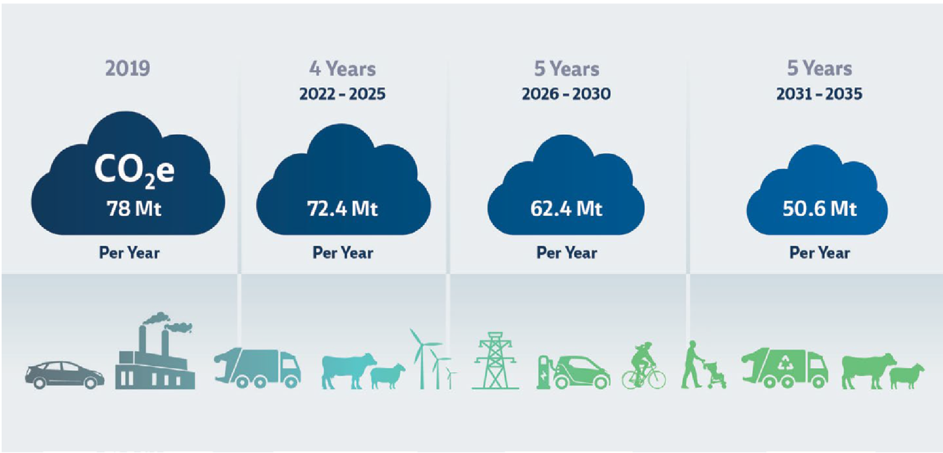
Source: Emissions budgets 2022-2025 (AR5) annual average emissions – Page 12 of the “Ināia tonu nei: a low emissions future for Aotearoa” report.

3.3 In grappling with this balance and responding to the Commission’s report, the discussion document views alignment of current systems and tools through the lens of seven themes. It is fair to say the discussion document also signals new tools will be required to achieve emission reductions in the long-term.
The seven themes are:
- Government accountability and coordination
- Funding and financing
- Planning
- Research, Science and innovation
- Behaviour change
- Shifting to a circular economy

4. Government accountability and coordination
4.1 The discussion document recognises that a coordinated central response is required to reduce greenhouse gas emissions over time to meet New Zealand’s 2050 targets.

4.2 The Commission recommended the Government work in partnership with iwi/ Māori and local government to embed the principles of Te Tiriti in the transition pathway to a low-emissions economy and the plethora of different strategies set out in the discussion document. The Government must work with iwi and hapū to co-design and implement new policy settings and measures that have a dual outcome of working to reduce emissions while at the same time addresses current [historical] inequities. The Commission was very clear that the design of policy needs to be cognisant of existing social disparities between communities and nuanced to avoid a one-sized-fits-all approach across the motu. This should be universally supported by iwi and hapū.

4.3 The Government also needs to adopt a leadership role in coordinating the different arms of central and local government to effectively implement policy and measures at scale to ensure interim reduction targets are met. Running hand in hand with central coordination is the Government committing to working with iwi and hapū to ensure implementation of policy and measures is effective and to provide feedback to improve implementation. Much can be learnt from the implementation planning around the COVID-19 vaccine roll out to Māori, Polynesian and non-European communities. These learnings should empower the Government to resource appropriately and work more closely with Māori, Polynesian and non-European communities to ensure the efficacy of new policies and measures.

4.4 Monitoring the effectiveness of re-worked and new policy settings and measures that underpin the emissions reduction plan is critical to its success. One part of the Commission’s role is to monitor and review the Government’s progress towards its emissions reduction and adaptation goals. There is a role for mātauranga Māori based indicators and monitoring systems to inform the Commission’s monitoring and reporting function. The Government will need to be cognisant of the Commission’s findings on effectiveness and any recommendations on fine-tuning or re-thinking aspects of policies and methods for future reductions plans.

5. Funding and financing
5.1 There is an acknowledgement that achieving New Zealand’s greenhouse gas emission targets will require significant and sustained investment in both the private and public sectors. The discussion document talks of ensuring “adequate, durable and certain” finance being available to fund the “transition to a low-emissions economy”.

5.2 The Government must, as a matter of course, articulate a vision for how the New Zealand economy will make the transition to zero carbon. There is much work to flesh out the “Getting to Carbon Zero” pathway diagram set out in the discussion document. It is all well and good to speak to transitioning to a low-emissions economy, but what does this look like in Hokianga versus Tūrangi versus Ōtepoti, and how will we shift at-risk communities to this outcome in a way that does not exacerbate existing inequities? This vexing question goes hand-in-hand with funding and finance and the prioritisation of resourcing that is provided to tackle those challenges. To a certain extent this canvassed through the low-emissions transition strategy lens provided by the Commission, but further work is required to nuance these approaches with mana whenua iwi and hapū, and Māori landowners.

5.3 The Commission has made it abundantly clear that the Government of the day will need to align public finance —through the successive budgetary cycles— to provide significant and sustained funding that can be readily invested in:
- science research and information [including mātauranga Māori] to develop elements of the bioeconomy and making the economy more circular
- research and development of innovative technology [to reduce gross emissions and in contrast to the use of mitigation offsets]
- design and implementation of nuanced public policy to transition at risk communities towards low-emissions economy [while also potentially addressing current inequities];
- powering up private public partnerships to commercialise new technology; and
- prioritising deployment of public policy and new technology to at risk communities

  - In doing the above, the Government must also recognise the unique situation of Māori land and ensure that Māori landowners are transitioned to a low emissions economy using nuanced policy settings that are co-designed by Māori and for Māori.

  - The theme of “for Māori by Māori” applies across the various sectors that are set out in some detail in the discussion document. For example, new “one-sized-fits-all” policy settings to incentivise the shift in light passenger vehicle fleet from internal combustion to hybrid/electric may operate perfectly well in towns and cities with critical mass and necessary infrastructure, but conversely may not be suited to remote regions with at-risk communities.

6. Emissions pricing
6.1 The New Zealand Emissions Trading Scheme (NZ ETS) is the main emissions pricing tool and is designed to send price signals to drive down emissions in line with successive interim targets and emission budget periods. The NZ ETS is a market-based instrument and relies on the Government regulating the market to generate the right price signals and over time by placing a cap on [or limiting] the emissions that sectors must surrender credits/obligations for [known as New Zealand Units (NZUs)].

6.2 All sectors of the New Zealand economy, with the notable exception of agriculture, pay for their emissions through the NZ ETS surrender obligations²⁰. This means that sectors are required to purchase and surrender one NZU for each tonne of CO₂e that is produced by their operations. Conversely sectors [mostly forestry] that remove CO₂e from the atmosphere are entitled to receive NZUs. A number of iwi, hapū and Māori landowners are familiar with the NZ ETS through the long-term operation of plantation forestry at scale.

6.3 However, there are a number of problems with the NZ ETS scheme that are highlighted in the discussion document. Principally the use of forestry to generate new NZUs [to offset NZ ETS surrender obligations] is largely unregulated/unmanaged. For example there is no control on where new forestry blocks are located and the unintended consequence of unmanaged land use change into afforestation [including the opportunity cost of not using that land for growing food] is not included in any decision.

6.4 The low cost of NZUs is also cited as a potential problem in that the price signal [or cost of abatement] is not clear enough to “force” sectors to adopt lower emission producing technologies. In other words, it is still cheaper to emit the same volume of greenhouse gasses and pay NZU surrender obligations, than to invest in lower emission producing technologies.

6.5 The Government needs to make some decisions around the utility of leaving the NZ ETS largely unregulated/unmanaged and allowing the market price dictate land use patterns. There are recent examples of market failure where the unmanaged land use change has resulted in unintended consequences in the form of environmental degradation. We should learn from these mistakes and not repeat them.

7. Planning
7.1 The current state of planning in Aotearoa under the Resource Management Act 1991 (RMA) has largely failed iwi, hapū and Māori landowners. It is unsurprising that the best examples of workable solutions to restore and protect customary, cultural and spiritual values [including the whakapapa relationship of Māori with Te Taiao] are found in Te Tiriti settlement legislation. A number of reviews of the RMA have also concluded it is not equipped to deal with the complex problems associated with a rapidly changing climate, let alone emissions reduction planning that is required to meet New Zealand’s agreed greenhouse gas emission targets.

7.2 The discussion document speaks to the overhaul of the current RMA and replacement with a new framework that is predicated on putting in place a consistent set of national direction that in turn directs the setting environmental limits which signals more strategically where development —within those limits— should occur. Planning instruments developed under the new Spatial Planning Act (SPA) and Natural Built Environment Act (NBA) would need to demonstrably uphold Te Oranga o te Taiao and give effect to the principle of Te Tiriti. As an indigenous framework, Te Oranga o te that mana whenua iwi and hapū must be engaged in the new system as both the co-framers of policy and joint decision-makers.

7.3 The proposed SPA may hold some of the keys to unlocking more integrated planning and to signal development of climate-appropriate infrastructure. However, the work to bring these new frameworks to fruition is in its infancy. The Freshwater Iwi Leaders Group (FILG) is heavily engaged with the Government on the development of the SPA and NBA.

7.4 The Commission recommended costing the impacts of climate change into the decision-making processes of Crown agencies, entities and Crown-owned companies, particularly investments into major capital works. This will be fundamentally important component of the SPA to avoid enabling development of infrastructure that is located in vulnerable places, is not fit for a low-emission economy future, or results in those assets being stranded [through a shortened life cycle].

7.5 A key consideration of future land use planning is to ensure that the many forms of development are integrated to ensure the interim targets set by the Commission are met through subsequent emission reductions and that those reductions are sustained into the future. It would be counterproductive to undermine historical emission reductions through land use decisions that are not integrated. Mana whenua iwi and hapū must be part of the decision-making frame for the development of the Regional Spatial Plans (RSS) and Natural Built Environment Plans (NBA plans), as well as the decision-making on applications/permits that implement key parts of RSS and NBA plans.

8. Research, Science and innovation
8.1 It is evident that innovation and advances in technology will be required to meet New
Zealand’s emission targets by 2050. The discussion document suggests the Government is committed to increasing funding for research, science and innovation activities up to 2% of GDP. While this is a starting point, the up to 2% increase in funding is below the 2.34% of GDP average spend for Organisation for Economic Cooperation and Development (OECD) countries. The Government should consider an emission budget period-on-emission budget period increase in funding to keep pace with future reductions signalled by the Commission.

8.2 As noted in previous sections, the Government must increase the resourcing provided to Crown Research Institutes (CRI) and access to funding for private research organisations to advance innovation and develop new technologies that result in a
gross reduction in greenhouse gas emissions. From a New Zealand perspective it would make sense to prioritise emission reduction research, science and innovation on the sectors where we have high capability and are considered world leaders. The Māori agriculture and forestry industry are based on principles that are more closely aligned to regenerative agriculture, bioeconomy and a circular economy. Therefore, it is imperative the Government engages closely with Māori agriculture and Māori forestry experts.

8.3 The Government needs to be cognisant that the private sector will not be incentivised to invest in research and development on new technology where there is no consumer demand for alternatives. Therefore, options for Mission-oriented innovation programmes —as described in the discussion document— are likely to be successful where the Government can focus research, science and innovation on finding solutions for specific problems, and to bridge the innovation gap between private sector investment into developing new technology and the commercialisation/deployment of that technology.

8.4 It is also worth noting that emission reductions to achieve Paris Agreement greenhouse gas targets is not solely a New Zealand problem. The international community is also grappling with similar problems. This provides an opportunity to partner with other countries to advance research, science and innovation to leverage access to new low emission technologies.

9. Behaviour change
9.1 The discussion document suggests the Government is committed to making an equitable transition to a low-emissions economy “that reaches targets, while minimising disruption and seizing opportunities”. There is a need to define what an “equitable transition” or a “just transition” looks like on the ground to whanau and hapū – what is “equitable or just” in the eyes of decision-makers in Wellington may not be “equitable or just” on the ground in Tikitiki or Murapara.

9.2 It is also important to note that transition will require considerable behavioural change in the habits of individuals, households and communities to reduce their emissions footprints. The problem is the ability of individuals and households to change their behaviour is not uniform across the motu. Policy settings that are designed to modify the behaviour and habits will need to be carefully nuanced to ensure that at-risk individuals, households and communities are not left behind and the existing social circumstances worsened. For example, setting a minimum price for petrol used in internal combustion vehicles [to encourage uptake of electric/hybrid alternatives] is likely to adversely affect at-risk individuals and households who are unable to afford electric/hybrid alternatives and/or who live in places where charging infrastructure does not exist, and public transport alternatives are not viable.

9.3 The Government will need to adopt the “for Māori by Māori” approach to ensure that policy design is fit for purpose and implementation of that policy translates to sustained and durable change in behaviour. Ideally behaviour change policies [to shift people to low emission alternatives] should work hand-in-hand with policies that seek to address historic inequity in the transition to a low-emission economy. There is also much overlap with the prioritised deployment of innovative technology to at-risk individuals, households and communities.

10. Shifting to a circular economy
10.1 The discussion document and the recommendations of the Commission place considerable emphasis on moving New Zealand to a circular economy or making the economy more circular.
10.2 A circular economy is effectively a system that operates within limits, maximises wellbeing and is said to be regenerative, circular and equitable. The discussion document helpfully describes the shift to a circular economy as “rethinking how we consume and produce all goods and services, how we live as individuals and communities, and our integration into global value chains”.
10.3 Iwi, hapū and Māori landowners are perfectly positioned to make the necessary shift to a circular low-emissions economy. The basic premise of operating within limits was previously advanced in the reform of managing freshwater as the fundamental concept of Te Mana o te Wai, and more recently is expressed in the reform of the RMA as Te Oranga o te Taiao. As noted in previous sections, Te Oranga o te Taiao [as an indigenous framework] necessarily means that mana whenua iwi and hapū must be engaged in the replacement legislation for the RMA as both the coframers of policy and joint decision-makers.
10.4 This places significant emphasis on the Government adequately resourcing and engaging early with mana whenua iwi and hapū and Māori landowners and Māori enterprises and businesses.
11. Transitioning key sectors
11.1 The discussion document provides specific detail about the transition pathway to reduce greenhouse gas emissions for different sectors, namely:
  - Transport [changing the way we travel, improving our passenger vehicles and promoting a more efficient freight system]
  - Energy and industry [preparing our highly renewable electricity sector to power the low-emissions economy, moving away from fossil fuels, and speeding up industrial decarbonisation through fuel switching and energy efficiency]
  - Building and construction [reducing building-related emissions, and realising health or other co-benefits where possible]
  - Agriculture [continuing to develop and adopt the technology and practices that keep this sector on track to meet the biogenic methane targets, and reduce long-lived emissions]
  - Forestry; [establishing forest sinks that remove carbon from the atmosphere and promote biodiversity and wider environmental outcomes where possible]
  - Waste [supporting the waste hierarchy, prioritising the reduction and diversion of waste from landfill (particularly organic), and reducing hydrofluorocarbons (HFCs) with high-global warming potential]

The Paris Climate Accord (Paris Agreement) was agreed at COP21 in December 2015 and came into force in November 2016.
http://www.legislation.govt.nz/bill/government/2019/0136/latest/whole.html
Refer to s5B of the CCRA 2002
Refer to s5O of the CCRA 2002
Refer to Page 12 of the “Ināia tonu nei: a low emissions future for Aotearoa” report
Refer to s5Q of the CCRA 2002
Refer to s5X of the CCRA 2002
Refer to page 23 of the “Transition to a low-emissions and climate-resilient future” discussion document
Refer to Section 5.2 – page 10-11 of the “Ināia tonu nei: a low emissions future for Aotearoa” report
Refer to page 22 of the “Transition to a low-emissions and climate-resilient future” discussion document
Refer to “The economics of climate change: no action not an option” Swiss Re Institute (2021) - https://www.swissre.com/institute/research/topics-and-risk-dialogues/climate-and-natural-catastrophe-risk/expertisepublication-economics-of-climate-change.html
Refer to Table 2 – Page 10 of the “Transition to a low-emissions and climate-resilient future” discussion document ¹³ Mt CO₂e equates to Megatonnes (million tonnes) carbon dioxide equivalent
Refer to Section 8.1 – page 140 of the “Ināia tonu nei: a low emissions future for Aotearoa” report
Refer to Page 16 of the “Ināia tonu nei: a low emissions future for Aotearoa” report
Refer to Page 25 of the “Transition to a low-emissions and climate-resilient future” discussion document
Refer to Figure 2 – Page 18 of the “Transition to a low-emissions and climate-resilient future” discussion document
Refer to Section 5.2 – page 10-11 of the “Ināia tonu nei: a low emissions future for Aotearoa” report
The sectors referred to in the Commission’s report and discussion document are: (i) transport, (ii) energy and industry [including fluorinated gasses (F-gases)]; (iii) building and construction; (iv) agriculture; (v) forestry; and (vi) waste ²⁰ Referred to as New Zealand Units (NZUs) which equate to one tonne of CO₂e
Refer to “Transforming the Resource Management system: Opportunities for change – Issues and Options paper (2019)
Refer to page 34 of the “Transition to a low-emissions and climate-resilient future” discussion document
Refer to page 48 of the “Transition to a low-emissions and climate-resilient future” discussion document
Note that advice is also provided for the use of fluorinated gasses (F-gases)

