NZ Hemp Industries Association. If you can't see this email, please click here.

The NZHIA
would like to extend an invitation to

Guest Name
to the NZHIA iHemp Discovery & Investment Tour

Kaikohe - Hui

Thursday 9 June 2022, 4:00pm
The Ngawha Innovation & Enterprise Park Office 21 Broadway Kaikohe 0405

Visit Tour website

The NZHIA iHemp Investment and Discovery Tour will promote the industry to key stakeholders, such as members of Maori/Iwi based groups, entrepreneurs, investors and the R&D communities, throughout Aotearoa New Zealand, to encourage their interest and participation in the iHemp industry.
Please join us for an afternoon of speaker presentations, networking
opportunities with iHemp business representatives.

Please RSVP by 03/06/2022 to:
Suzanne Hall, suzanne.hall@ngawhainnovation.co.nz

- New Zealand Hemp Industries Association -
Promoting the Economic, Environmental, Health and Social Benefits of the NZ Hemp Industry

Directory
Membership
Events
About

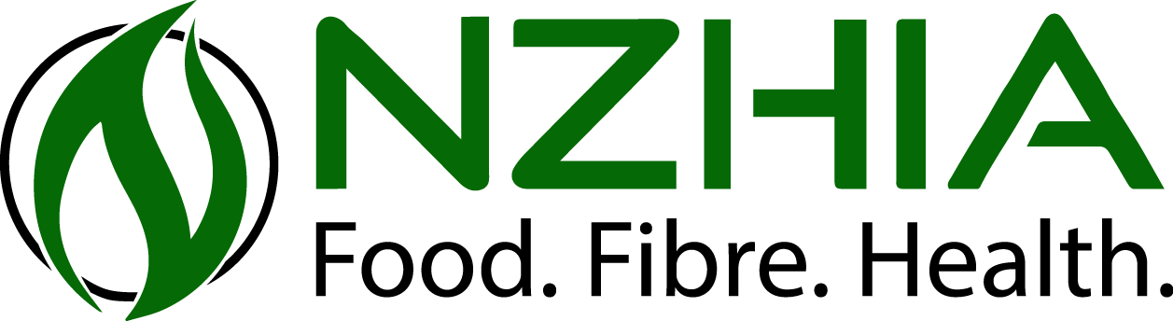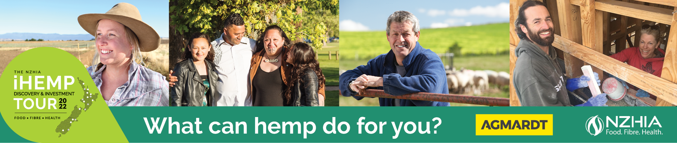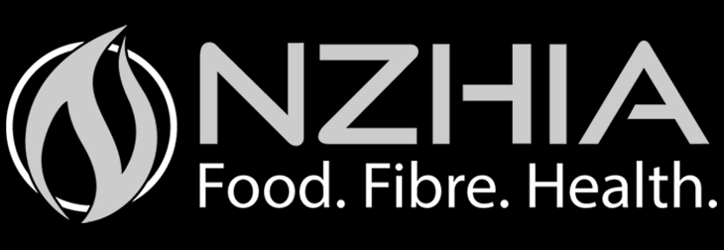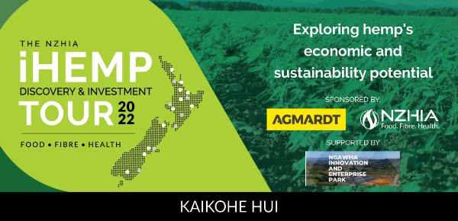
You have received this email as someone who has contacted or been contacted by the NZ Hemp Industries Association Inc.
|

You are receiving this email because you have communicated with the NZHIA or the economic development agency hosting the event/meeting.
Unsubscribe | Update Preferences | Customer Support

