NZ Hemp Industries Association. If you can't see this email, please click here.

The New Zealand Hemp Industries Association are pleased and honored to invite
VIP Guest Name
to the NZHIA iHemp Discovery & Investment Tour
Whangārei Regional Meeting

Wednesday 8 June 2022, 7:00pm - 10:00pm
McKay Stadium - McKay Lounge 97 Western Hills Drive, Kensington

This is an evening to explore hemp’s economic and sustainability potential by optimising use of Māori freehold land within the Northland region.

Our goal is to help develop a collaborative network that will allow for the scaled growth of this emerging industry in the area, as part of a larger plan to develop Aotearoa's newest primary industry.
With special thanks to
Ngawha Innovation & Enterprise Park for their support

Your Complimentary Ticket

Please select 'Get Tickets' and 'VIP - Complimentary', where your VIP access code will be automatically applied.
Continue through registration details and you will receive your email confirmation.

- New Zealand Hemp Industries Association -
Promoting the Economic, Environmental, Health and Social Benefits of the NZ Hemp Industry

Directory
Membership
Events
About

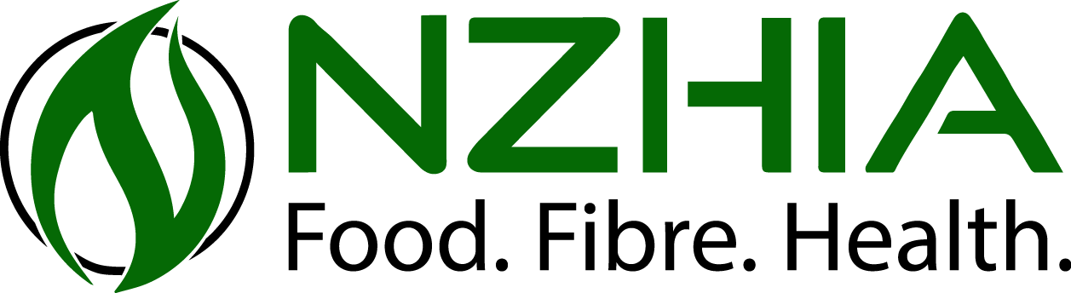
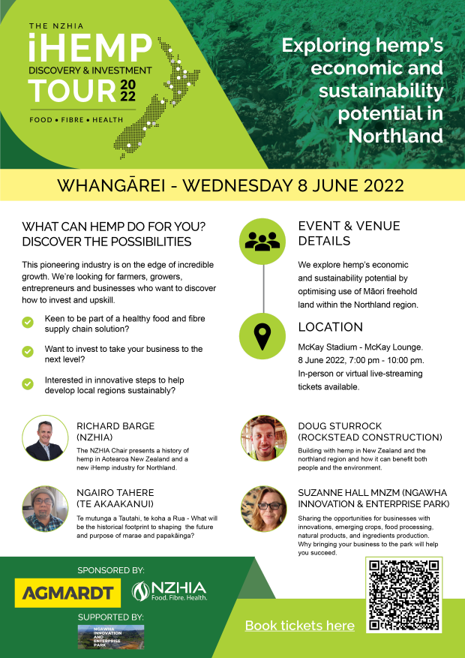
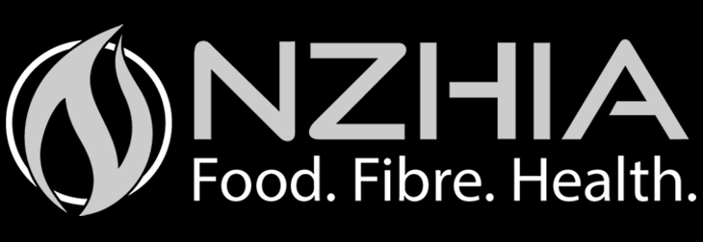
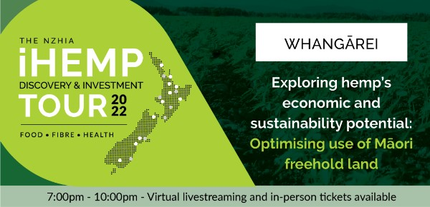

You have received this email as someone who has contacted or been contacted by the NZ Hemp Industries Association Inc.

You are receiving this email because you have communicated with the NZHIA or the economic development agency hosting and/or supporting the event/meeting.
Unsubscribe | Update Preferences | Customer Support

