Application for Resource Consent for Floodway at Kaeo River SH10 Bridge

Applicant - Northland Regional Council (Community Resilience -Rivers)
Northland Regional Council Private Bag 9021 Whangarei 0143

Contact person - Meg Tyler
megt@nrc.govt
0212632820

Proposed Regional Plan for Northland (PRPN)

Coastal Activities consent
- Rule C.1.4.7 ‘Mangrove removal’ – discretionary activity
- Rule C.1.5.15 ‘Dredging, deposition and disturbance activities for operation, maintenance, repair or upgrades, associated with state highways’ – discretionary activity

Land use consent
- Rule C.2.1.11 ‘Activities in the beds of lakes and rivers’ – Discretionary
activity.
- Rule C.2.1.14 ‘New flood defence’ – Discretionary activity.
- Rule C.3.1.9 ‘Obstructions that divert water onto other property’ –
Discretionary activity.
- Rule C.4.1.7 ‘Other land drainage and flood control activities’ – Discretionary
activity.
- Rule C.8.3.4 ‘Earthworks’ – Discretionary activity.

The activity to which the application relates (the proposed activity)

The proposal is to extend the floodway downstream and upstream of the new State Highway 10 bridge over the Kaeo River located approximately 2.5km north of Kaeo. This proposal extends the floodway into the Hayes property downstream of road corridor land parcel and widens the floodway on to the Kerr property upstream of the bridge.
The works are intended to maximise the quantity of flood water that can pass downstream under the new bridge but not alter the level of flood protection provided to the adjacent properties by the current river banks. This work has route security benefits reducing the flooding across SH10 500m west of the bridge in small flood events.

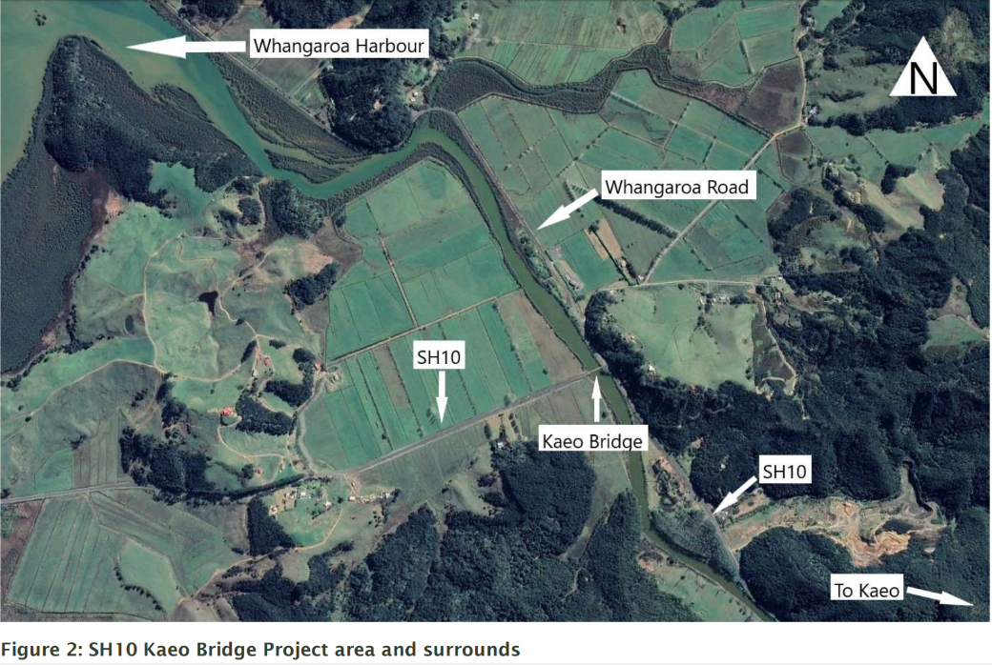

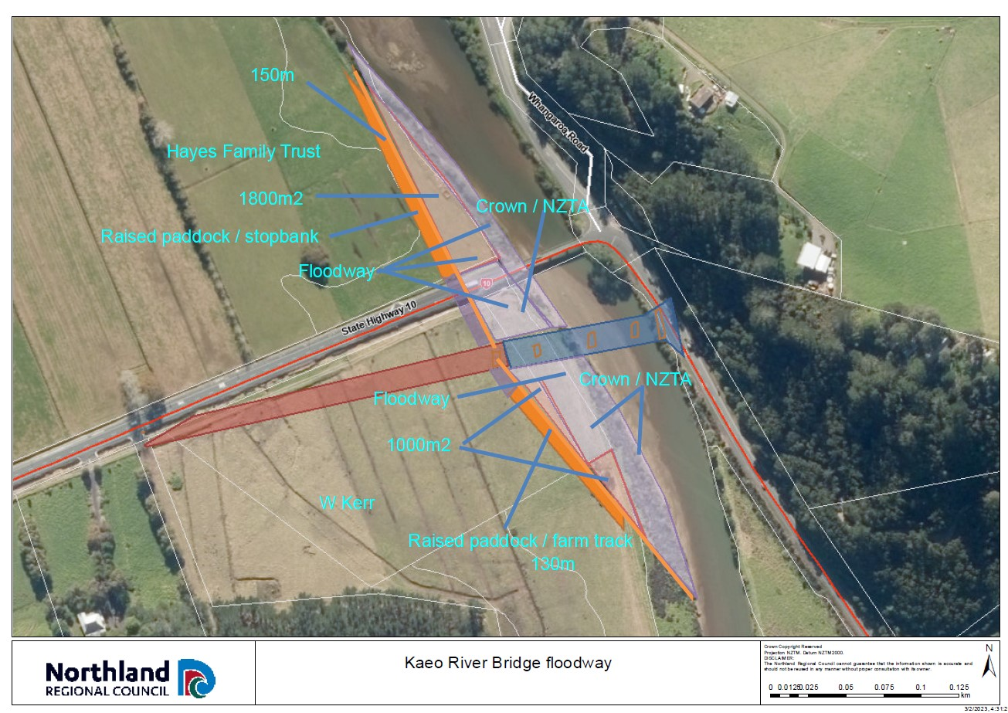

Plan detailing the location of proposed stopbanks and floodway, Kaeo SH10 bridge

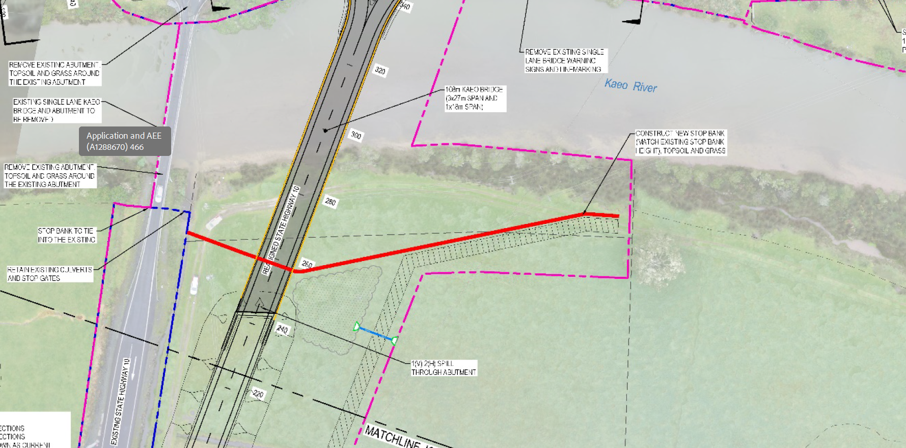

Consented bridge construction and associated works AUT.041470.01.01

Details of the proposed works covered by this application

- Lowering of the elevated land immediately beside the river by approximately 250-500mm to the lowest paddock level for approximately 100m upstream and 150m downstream of the new bridge to create a flood way leading into and away from the bridge.
Note, the riverbed area downstream the old bridge is Coastal Marine Area.
Note. Excavating the flood way to stream bed level upstream of the bridge is not possible without relocation 5 power poles and associated infrastructure from the floodway at an estimated price of $180-$230 000. This will not be considered unless scheduled modelling shows significant flood mitigation benefits.

- Upstream of the new bridge. Clearance of a portion of the riparian vegetation for approximately 250m upstream. The vegetation is predominantly the pest plant sharp rush (Juncus acutus) and occasional mangrove. Sharp rush is an exotic weed and is a ‘Sustained Control’ pest plant in the Northland Regional Pest and Marine Pathway Management Plan.

- Downstream of the new bridge. Clearance of the riparian vegetation for approximately 150m downstream. The vegetation is a narrow strip fronted with mangroves with sharp rush filling the area back to the riverbank. This is in the Coastal Marine Area (CMA) as the old bridge is the boundary of the CMA.

- Upstream of the new bridge. Clearance of accumulated sediment from the riverbed for 300m upstream of the new bridge.

- Downstream of the new bridge. Clearance of accumulated sediment from the coastal marine area for up to 150m downstream of the bridge.

- Upstream of the new bridge. Placement of fill on a flood plain to construct a low stopbank bank with a 1:5 edge slope. The area is mapped as being in the 10 year flood hazard zone. It is to extend from the floodgate beside the bridge headwall back to the existing riverbank approximately 100m upstream, with a finished height the same height as the existing riverbank / farm track. It will be located primarily on the road reserve but will extend into William Kerrs adjacent property. It will be gently contoured. It will provide no more or less protection than the existing riverbank provides. Construction of a stopbank in this general area is permitted in the consent for the bridge construction and associated works. The stopbank will not extend outside the bridge designation area onto the Kerr property without the written permission of Mr Kerr

- Downstream of the new bridge. Placement of fill on a flood plain to construct a low stopbank /filled area on the flood plain. It is to extend from the bridge headwall downstream to the existing riverbank approximately 150m downstream, with a finished height the same height as the existing riverbank. It will be located primarily on the Hayes family trust property and joined to the bridge embankment across the road reserve. The work on the road reserve is covered by the resource consent for the bridge and associated works. The paddock side of the stopbank contoured so that it blends into the paddock and can be mown. It will provide no more or less protection than the existing riverbank provides.

Affected properties

Downstream of bridge

- Amelia Judith Lorelei Hayes, Ian Lionel Hayes, SH&P Trustees Limited Representative Nick Hayes
Lot 4-5 Deposited Plan 32504 and Section 19, 28 Block II Kaeo Survey District,

2) CMA Hydro parcel

Upstream of bridge

- Keith William Kerr
Lot 1\DP 119867, Pt Lot 6\DP 32504
4) Road reserve
Lot 2\DP 119867
- Hydro reserve

Consultation and approvals

- Hayes Family Trust Approval given and Licence to Occupy agreed to. Approval given to apply for Archaeological Authority from Heritage New Zealand
- Road reserve and Hydro parcel. Approval given with bridge consent
- Kerr. In negotiation re extension of floodwall onto Kerr property. Work on adjacent road reserve parcel agreed by NZTA and accepted by Kerr as is this is not Kerr land. No work will be undertaken on the Kerr property without written approval.
- Whangaroa Maori Trustboard. Consultation underway. Draft consent document emailed 06/03/2024. Contact people Violet Walker, email kaiarataki.ngapuhi@gmail.com , Bryce Smith 0210341963. Email response received.

- Te Runanga o Whaingaroa. Consultation underway. Draft consent document emailed 06/03/2024. Contact person Raniera Kaio 021 2957306 email Raniera.Kaio@whaingaroa.iwi.nz Awaiting a response.

Consents current at or adjacent to this location.
- Bridge construction and associated works AUT.041470.01.01
- Gravel extraction from the bed of the Kaeo river Aut.009390.01.02

Extract from AUT.041470.01.01 Northland Bridges Kaeo General Arrangement Plan Sheet 2

Assessment of Environmental Effects

A comprehensive assessment of environmental affects accompanied the NZTA bridge application APP.041470.01.01 Application and AEE-Finalised 22-07-2020.pdf

Site details

The site is the Kaeo riverbed, the adjoining road reserve and farmland for 150m downstream of the old bridge and approximately 250 m upstream of the new SH10 bridge approximately 2.5km north of Kaeo township.
- The old bridge location 50m downstream of the new bridge is the boundary of the Coastal Marine Area (CMA).
- The riverbed downstream and upstream of the bridge is consented for gravel extraction.
- The area of road reserve and riverbed hydro parcel containing the old bridge old bridge and to about 100m upstream of the new bridge is consented for bridge construction, old bridge deconstruction and associated works in and beside the river.

Built environment
The new bridge is approximately twice the span of the old bridge that has been replaced. The Kaeo River overtops its banks for 350m upstream of the new bridge location in all except very small flood events. The flood waters then flow down across the Kerr property to the base of the hill 700m west of the bridge and over tops the SH10. This closes the road to all traffic in small-medium or big flood events. Surveys of past floods have shown a 250mm decrease in river flood level immediately downstream of the old bridge compared to immediately upstream.

These works are intended to maximise the quantity of flood water that can pass downstream under the new bridge to minimize the flood height differential around the bridge and reduce the riverbank overtopping and road flooding. They are an enhancement of the floodway consented by the bridge consent ,extending the floodway across the corner of the Hayes property downstream of the area currently consented.

Ecology

Extract from APP.041470.01.01 Application and AEE

Section 3.1.6
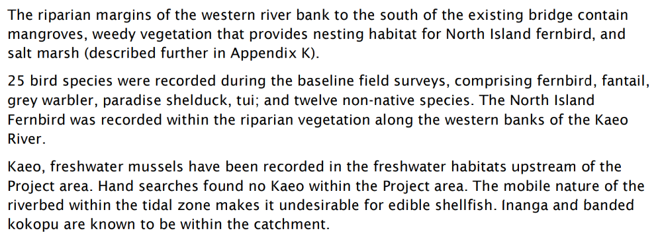

Only a small proportion (2.5%) of the riparian vegetation in the general locality is affected by this application and much of that will be replaced with beneficial native species. Downstream of the bridge approximately 0.09ha of mangrove and the exotic weed ‘sharp rush’ is to be removed. Upstream of the bridge worksite, approximately 0.1ha of mangrove and rush (mainly sharp rush) is to be replaced or removed. There is approximately 6.2 ha of mangrove and saltmarsh vegetation within 1000m of the bridge. There is approximately 1.4ha of riparian wetland vegetation and 4.5ha of rough pasture / rush and a woodlot with dense grass and shrub understory within 1000m upstream of the site.
It is expected that the parts or all of the floodway will be submerged with brackish water during very high tides. Two power poles are in the fringe of the riparian area and would potentially be destabilized if the riparian vegetation was removed. To reduce this risk the mangroves and the sharp rush near the poles will be progressively replaced with the native Oi Oi, Apodasmia similis, (jointed rush) which has a shorter stature and is not as rigid and impeding flood flows to the same amount as the current vegetation.
Downstream of the bridge, the river and stopbank edges totalling approximately 600m2 will be planted in Oi Oi to mitigate the ecological habitat effects and prevent erosion.

Extract from APP.041470.01.01 Application and AEE
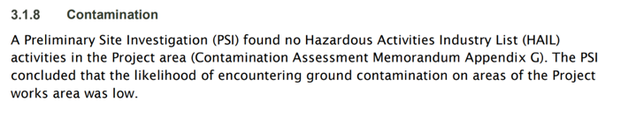
Inspection of the derelict piggery and associated concrete tank revealed the presence of asbestos containing material (acm) that had been used as roofing material for the tank and some of the cladding of the building. This will be removed and disposed of by accredited contractors.

Extract from APP.041470.01.01 Application and AEE

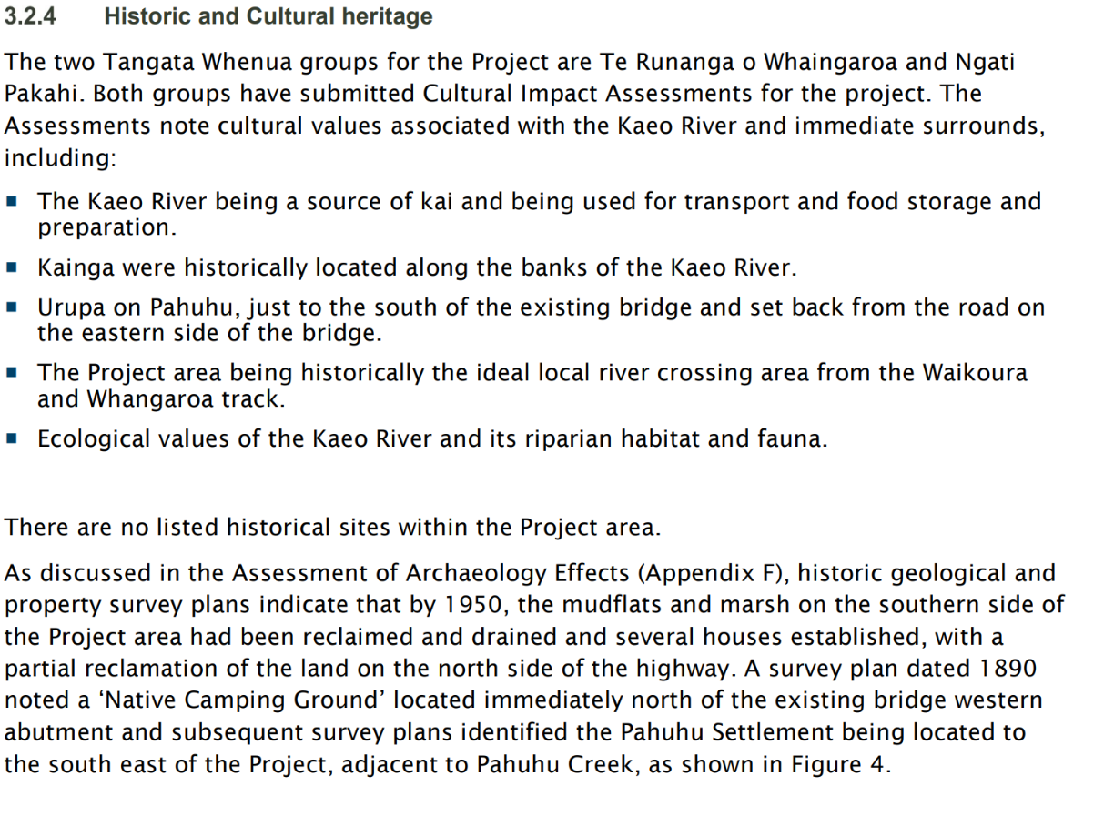
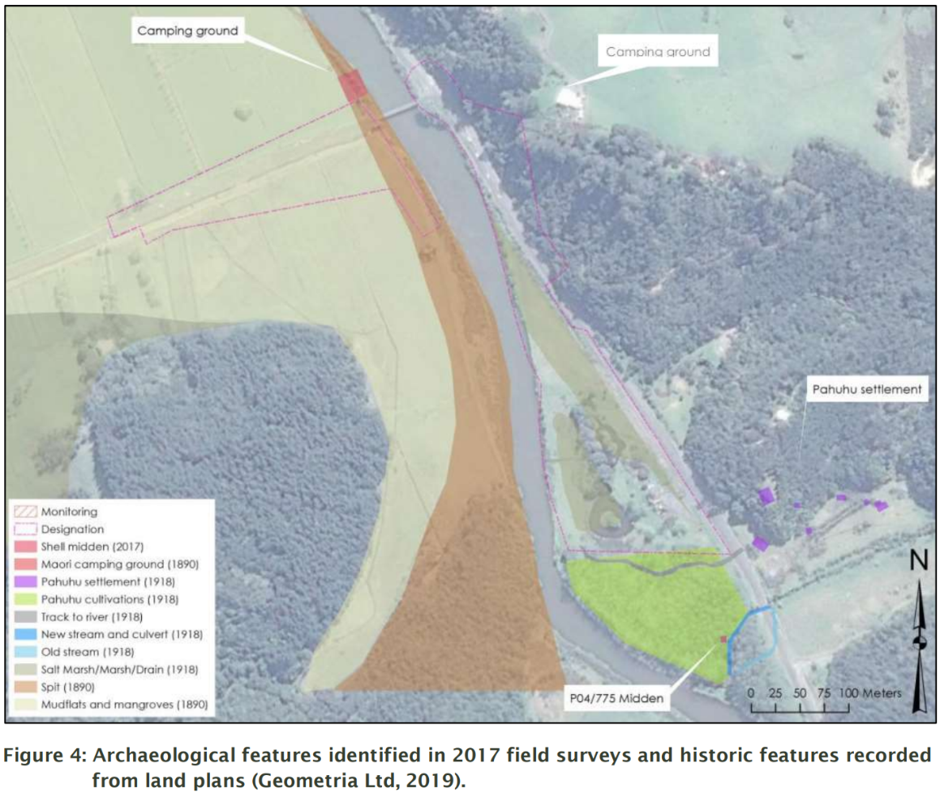

Proposed earthworks will disturb the area marked as ‘Native Camping Ground’ on the 1890 survey plan immediately downstream of the old bridge location. There is a current general Heritage NZ Archaeological Authority in place issued to NZTA for works within the bridge work area. A new Authority is being applied for the to cover works on the downstream Hayes property with Geometria Ltd, Jonathan Carpenter, the archaeologist managing this issue.

Extract from APP.041470.01.01 Application and AEE

